SOUTH AFRICAN BANK NOT RECOGNITION

207502969

2013

SENZO MAPHUMULO

School of Computer Science

5/31/2013

**IMAGE PROCESSING PROJECT**

**(South African Bank Note Recognition)**

**Introduction**

This document contains a report about the classification of South African bank notes from the old R10 to the new R200.Classification is performed on both sides of the note. The system uses various algorithms studied in the course to display and classify the image; and is carried out in four stages namely preprocessing and enhancement, segmentation, features extraction and classification.

**Bank Note Preprocessing**

The images loaded to the system are converted to gray scale before processing. One method was tested for preprocessing, namely threshold which binaries the image.

**Bank Note Enhancement**

The system is implemented with the following image enhancement techniques:

* Ratio Image
* Negative Image
* Log
* Mean Filter
* Median Filter
* LBC
* Histogram Equalization

A sample image will be displayed for each technique used.

**Ratio Image**

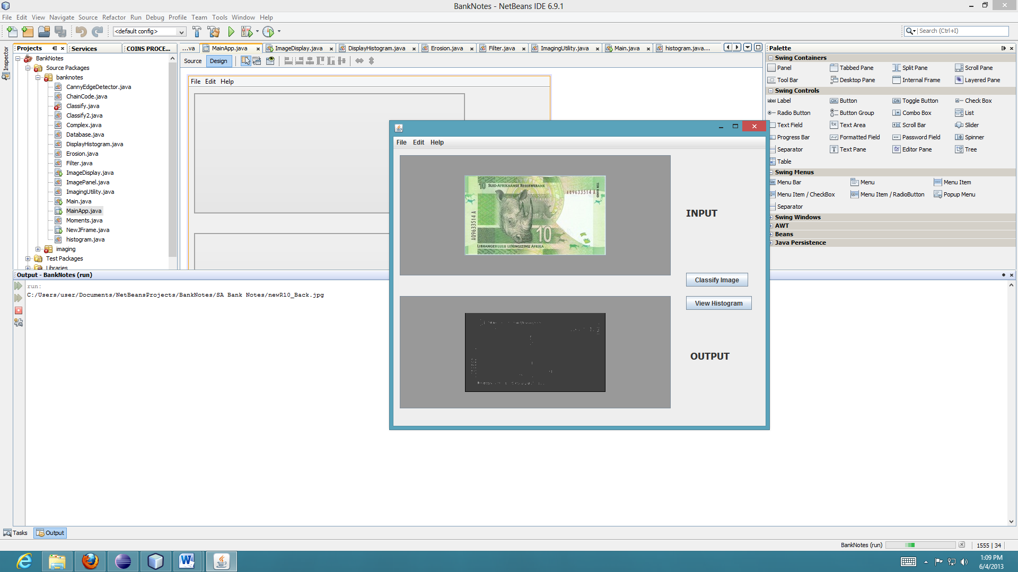

It is not really easy to the image after the ratio.

**Negative Image**

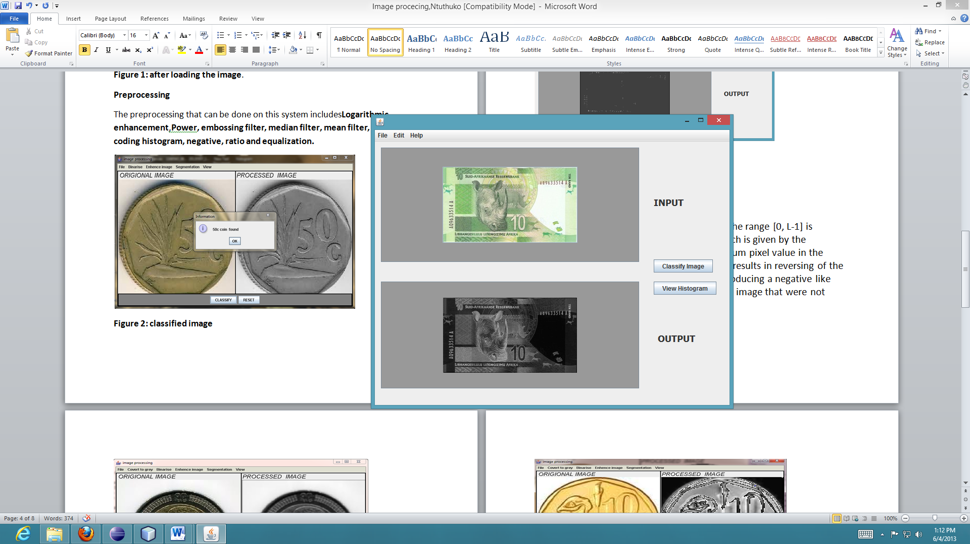

The negative of an image with grey levels in the range [0, L-1] is obtained by the negative transformation which is given by the expression: s = L - 1 – r, where L is the Maximum pixel value in the image and r is the pixel value. This operation results in reversing of the grey level intensities of the image thereby producing a negative like image. It makes it easy to see the parts of the image that were not visible before performing it.

**Log**

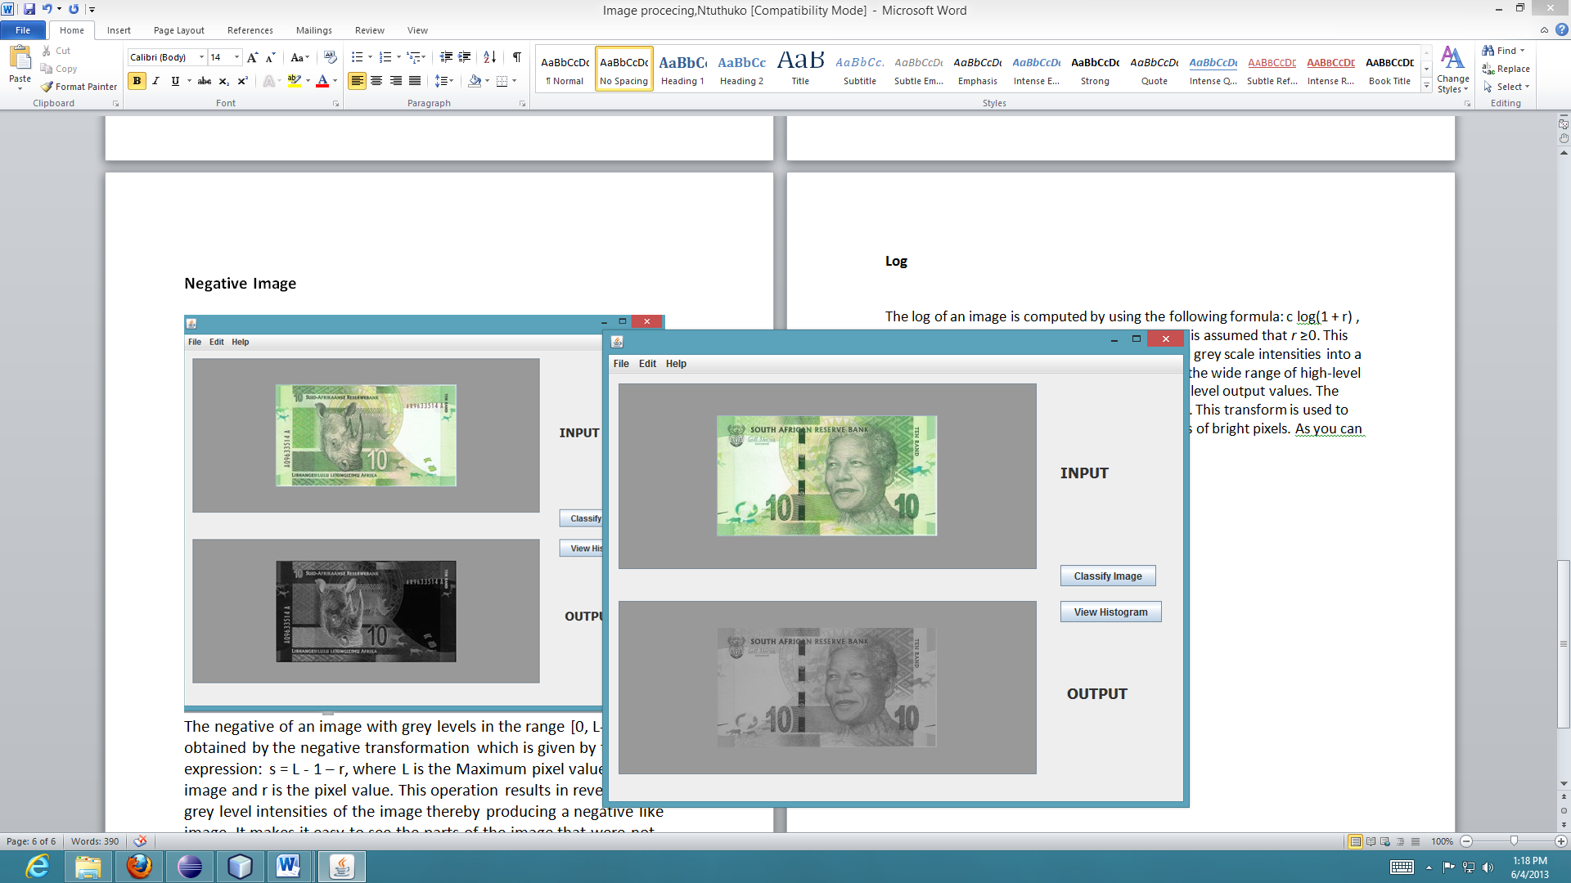

The log of an image is computed by using the following formula: c log(1 + r) , where r is a pixel value and *c* is a constant and it is assumed that *r* ≥0. This transformation maps a narrow range of low-level grey scale intensities into a wider range of output values and similarly maps the wide range of high-level grey scale intensities into a narrow range of high level output values. The opposite of this applies for inverse-log transform. This transform is used to expand values of dark pixels and compress values of bright pixels. As you can observe from the images above.

**Mean Filter**

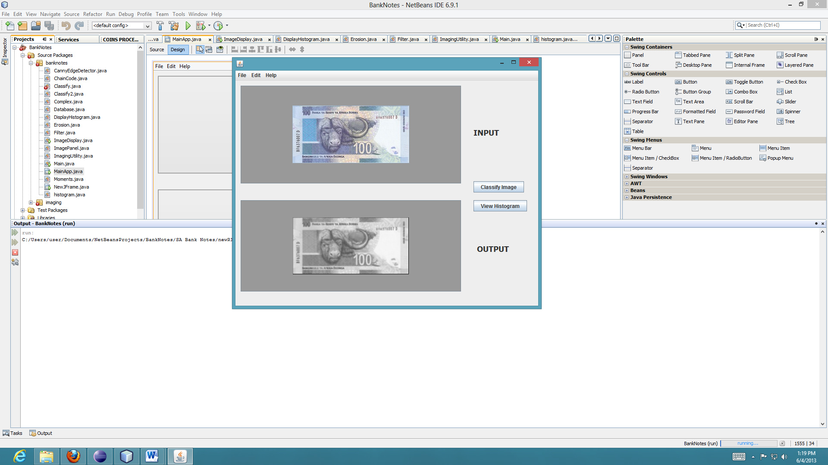

**Median Filter**

Median Filter does what is almost the same as the mean filter, but, instead of taking the mean or average, it takes the median. The median is calculated by sorting all the values from low to high, and then taking the value in the center. If there are two values in the center, the average of these two is taken. A median filter gives better results to remove salt and pepper noise, because it completely eliminates the noise.

**LBC (Local Binary Coding)**

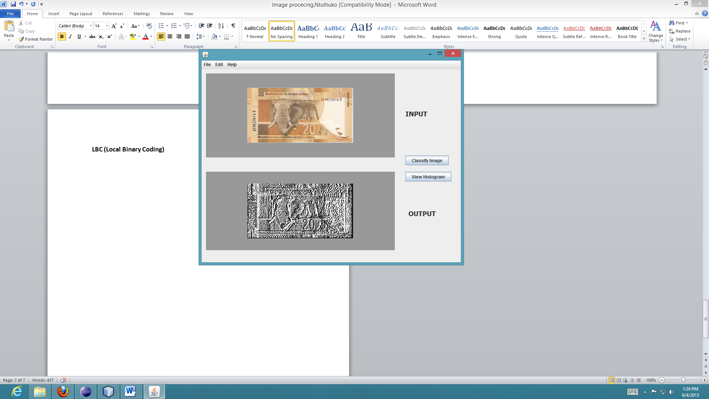

**Histogram Equalization**

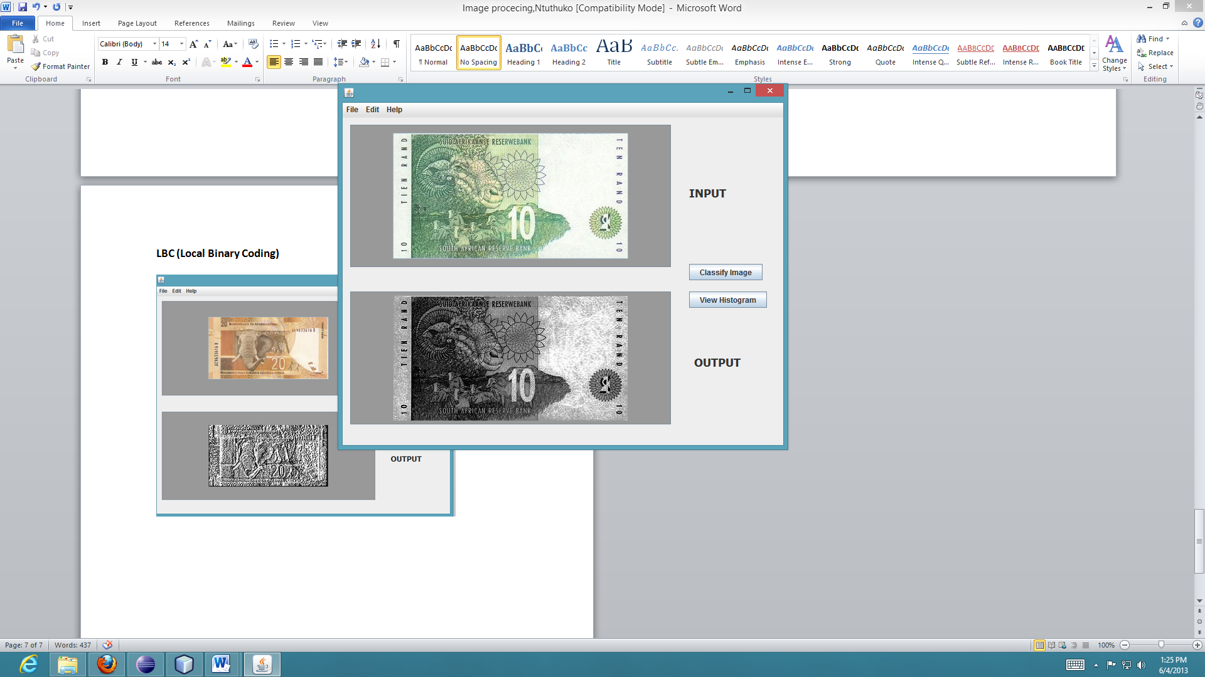

The Histogram equalization spreads out the most frequent intensities of an image such that their distribution is balanced, In other words, HE increases the global contrast of an image, especially when the usable data of the image is represented by close contrast values. The type of HE we used is the cumulative HE technique.

**Segmentation**

Two methods were attempted used for segmentation: **erosion** and **dilation**.

**Erosion**

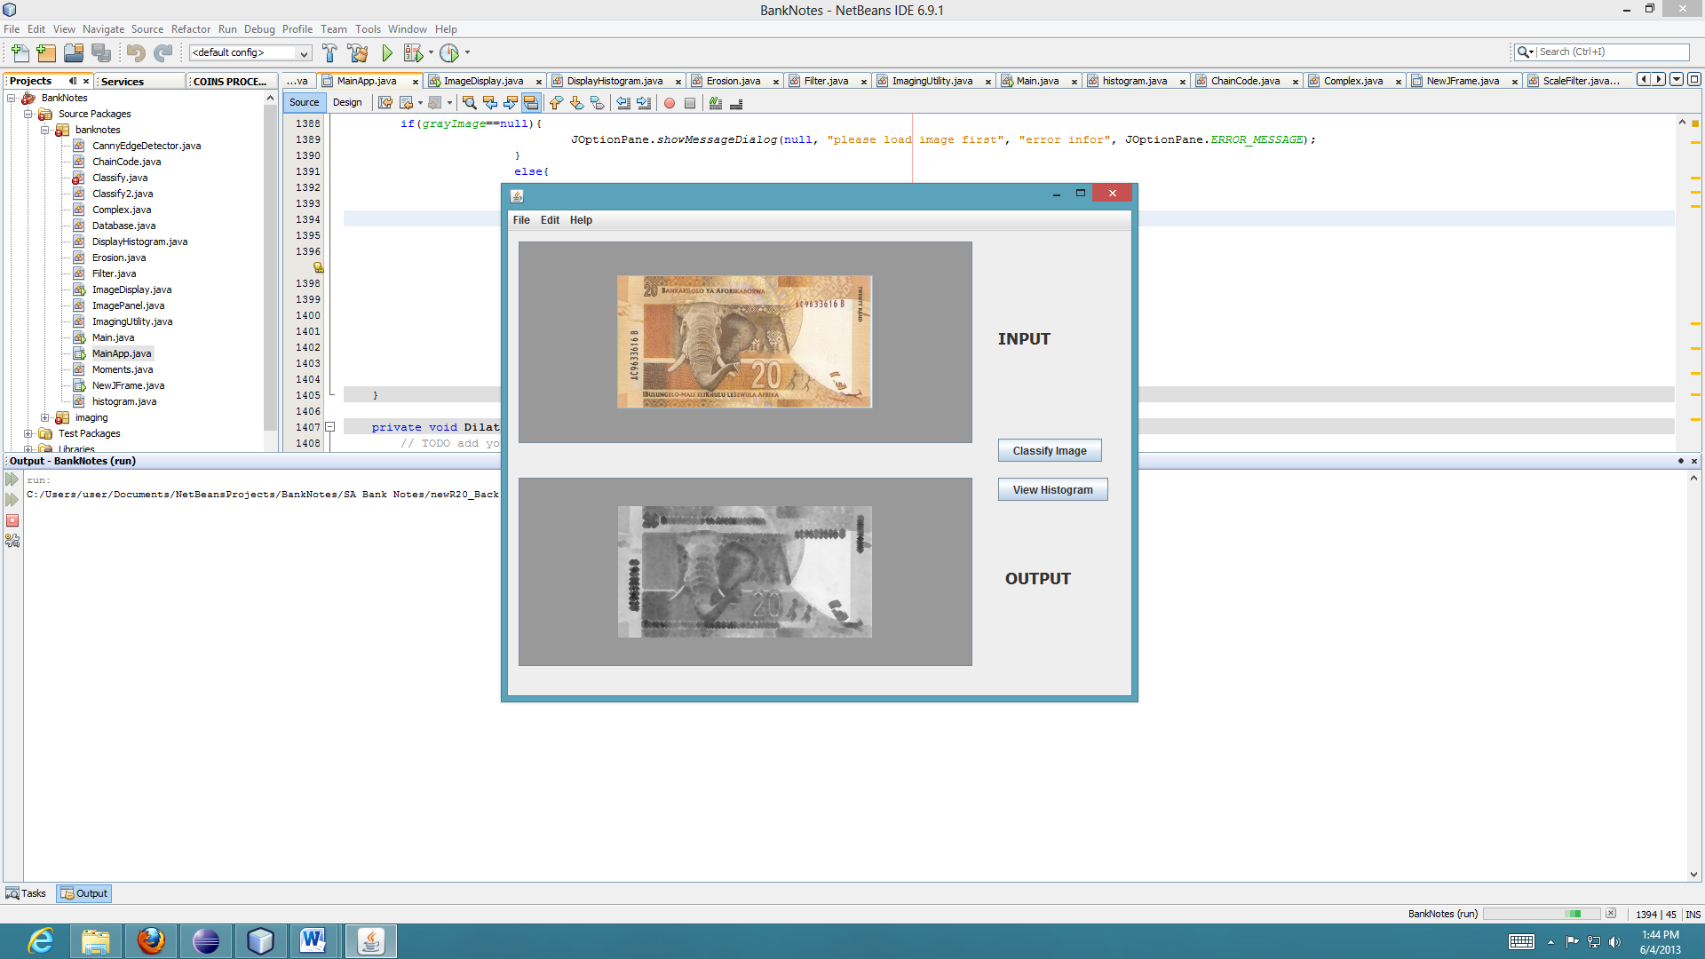

**Feature Extraction**

The system uses the seven invariant moments after extracting features from the menu tab.

**System Success Rate**

With the aid of the invariant moments it is much easier to perform valid classification. The System has a higher percentage success rate although in some instances it misclassifies a note because of mainly the image size or the type of the background that is present on the image.